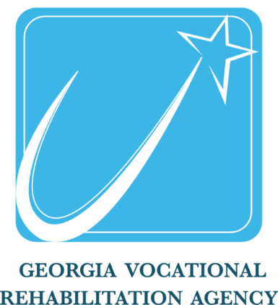

Employment and Independence
for Georgians with Disabilities

(844) FOR-GVRA / (844) 367-4872
wecare@gvs.ga.gov

FACTS
GVRA clients with job placements earn 24% more on average than minimum wage.
GVRA serves tens of thousands of Georgians every year.
Employers who hire individuals with disabilities report increased profitability.

HOW IT WORKS
Trained certified counselors and other professionals provide services to help eligible
persons with disabilities prepare for, start and maintain competitive employment.

SERVICE AREAS
With offices statewide, we are available to assist individuals with disabilities and
employers across Georgia. Where you see GVRA, you find a range of services available to
those who qualify.

WHO CAN BE A CLIENT?
Your disability must be permanent and affect your ability to work. Each person’s
situation is considered individually. Contact your local office for additional information. You can find your local office at: https://gvs.georgia.gov/

SERVICES, INDIVIDUALIZED TO CLIENT NEEDS, MAY INCLUDE:
- Assistive Work Technology
- Vocational Training
- Skills Assessment
- Job Placement Support
- Counseling and Guidance
- Post-Secondary Support
- Supported Employment
- Work Readiness Training

gvs.ga.gov

(rf/ea/20112)

♦ TO GET YOU WORKING ♦

The Purpose of Vocational Rehabilitation Services is to: “Assist People with Disabilities to Work”

Who can apply for Vocational Rehabilitation Services?

You can apply for vocational rehabilitation services if you have a physical, mental or emotional disability that interferes with your ability to work and you need vocational rehabilitation services to work.

Applying for Services

You will meet with a counselor and fill out an application for the VR Program. You and your counselor will get documentation of your disability to determine if you qualify.

How do I Qualify?

You may qualify for vocational rehabilitation services if you have a permanent disability, which is substantially affecting your ability to work. Your counselor will let you know as soon as possible if you qualify.

Work Needs Assessment

You and your counselor will make choices about available services you will need to reach your employment goals. Your counselor may schedule you for tests to find out what services you need.

WORK PLAN

You and your counselor will develop a work plan that lists your responsibilities and the services you may receive.

Vocational Services

Services will be based on your individual needs for the purpose of working.

Closure

Your case may be closed after you have been employed successfully for 90 days.

Services after Closure

You can request additional services after your case is closed if they are needed to keep you working.

How long will this take?

The length of time is different for each person depending on the services needed to go to work.

YOUR RESPONSIBILITIES

VR will help you go to work but we need your help in this effort as well. Below are some of these responsibilities.

- Keep appointments & stay in contact with your vocational counselor

- Give honest & complete information

- Tell your vocational counselor about changes in your situation

- Help develop your work plan & work hard to complete it

- Do what’s in your work plan and any amendments (changes) to it

- Use other benefits

- Get written approval before expecting the VR Program to pay
